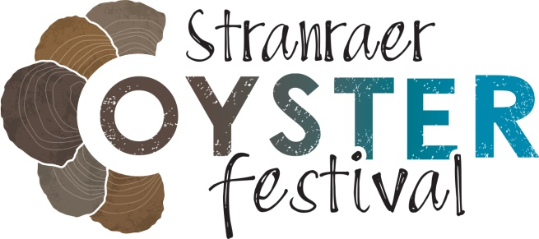
Media Release: 21 August 2023

Night aerobatic air display and aircraft pyrotechnics added to Stranraer Oyster Festival Programme
An aerial pyrotechnic aerobatic display is set to wow the crowds at Stranraer Oyster Festival next month. Two night displays are planned over Loch Ryan in south west Scotland, home of the last wild, native oyster fishery in Scotland, on the evenings of Friday 15th and Saturday 16th September.

A few lucky festival-goers will even get a front seat view! Members of the public will have the chance to secure a once in a lifetime experience on a formation flight, taking place on Sunday 17th September. There are eight seats up for grabs, four will be raffled and auctioned at the Big Oyster Bash on 2nd September, and the remaining flights will be raffled and auctioned on Friday and Saturday at the festival. The winners of the flights will take the front seat, beside the pilot, as the planes undertake manoeuvres over Loch Ryan.

The display has been organised to draw attention to the scenic natural amphitheatre of the Loch Ryan sea loch. Festival crowds will gather on the southern curve of Loch Ryan, looking north towards Ailsa Craig, to watch two skilled pilots flying in close formation, discharging pyrotechnics and LED lightshows from the wings of their aircraft, to create a stunning airborne spectacle. Replacing the traditional opening evening fireworks, the aerobatics displays will take place just after sunset.

The display is being organised by Airshow Scotland, the company behind The Scottish International Airshow. Spokesman Doug Maclean said:
“To see these kinds of aeroplanes flying in close formation, illuminated by their own lighting while carrying out aerobatic manoeuvres is very exciting. They’re incredibly graceful and highly manoeuvrable, and this pyrotechnic display over Loch Ryan is going to be very special indeed.”

“We are thrilled to be able to bring a display of this calibre to Stranraer Oyster Festival and we’ve taken the festival’s focus on sustainability on board. These aircraft are, by their nature, very lightweight, with highly efficient engines that use a surprisingly low amount of fuel, and by using nearby Castle Kennedy airfield the environmental impact is minimised.”

Romano Petrucci, Chair of Stranraer Development Trust, the community organisation that organise Stranraer Oyster Festival, explained:
“As the day fades and the night rises, everyone attending Stranraer Oyster Festival will see the spectacular sight of these amazing aircraft lighting up the sky above Loch Ryan with their graceful aerobatic manoeuvres. This is something we have wanted to bring to the festival for years, and we are absolutely thrilled to have the expertise and professionalism of Doug and his team creating this magical display.

“It’s the first time a night aerobatic display will have taken place over Loch Ryan, and our goal is to connect visitors to the festival with the sea and the sky as they look out over the water to the precious native oyster bed. I am thrilled that we’re able to offer some lucky festival-goers the experience of winning a front seat on the Sunday flights. It’s going to be absolutely incredible.”

Taking place from Friday 15th to Sunday 17th September, Stranraer Oyster Festival has quickly become established as one of the biggest food festivals in Scotland, and a must-visit for oyster enthusiasts, with visitors attracted from all over the UK.

The environmental impact of the display has been factored into the festival’s sustainability plan, with the engines in the low-emission gliders considered comparable to that of a small car. The aerobatic pyrotechnic displays are an addition to an already-packed festival programme, which includes demonstrations from celebrity chefs Michael Caines, Tony Singh and Julie Lin, live music, the Scottish Shucking Championships and much more.

First launched in 2017 by Stranraer Development Trust to promote the area as a tourism destination, the festival has had a huge impact on Stranraer’s economy, and its identity. After four festivals, independent economic analysis demonstrated that Stranraer Oyster Festival has generated almost £5 million for the local economy so far, supporting hundreds of jobs and helping to change the story of Stranraer from one of economic decline to a story of tourism potential.

The festival is supported through Dumfries and Galloway Council’s Major Events Strategic Fund and Coastal Benefit Fund, and EventScotland’s National Events Funding Programme. The work of Stranraer Development Trust is also supported by Kilgallioch Community Fund and South of Scotland Enterprise.

Tickets cost £6 per day or £12 for the full three-day event for over 12s, with concessions available. Additional charges apply for selected chef demonstrations.

General admission tickets for Stranraer Oyster Festival 2023 can be purchased from www.stranraeroysterfestival.com

Ends

Photos:
The attached photos of previous aerobatic displays have been supplied by Airshow Scotland for promotional purposes and are free to use.
A wide selection of photos of previous Stranraer Oyster Festivals are available on request.

Contact details:
Romano Petrucci of Stranraer Development Trust can be contacted on 07711 034200
For PR enquiries or press passes for Stranraer Oyster Festival contact Lorna Young on 01387 263 886 or email: lorna@indigowords.co.uk

Stranraer Oyster Festival welcomes the opportunity to raise awareness of the festival through extended features or broadcasts. Interviews and visits out on the oyster boat are possible by arrangement. Please contact Lorna Young to discuss.

EVENTSCOTLAND – Notes to Editor

EventScotland is working to make Scotland the perfect stage for events by securing and supporting an exciting portfolio of sporting and cultural events. It provides funding opportunities and access to resources and information to develop the industry.

EventScotland is a team within VisitScotland’s Events Directorate, the national tourism organisation, alongside Business Events and Development teams. For further information about EventScotland, its funding programmes and latest event news visit www.eventscotland.org or follow Twitter @EventScotNews and LinkedIn.

